Miyazaki International College
Course Syllabus
2021 Spring

Course Title ( Credits ) | GSC101: Introduction to Information and Communication Technology (4 credits)
Course Designation for TC | Required by Article 66.6
Content Teacher
Instructor  E-mail address  Office/Ext  Office hours | Anderson Passos, Ph.D. (実務経験のある教員)  apassos@sky.miyazaki-mic.ac.jp  MIC 1-315/Ext. 3725  Monday to Friday from 13:00 to 14:30
Teaching Assistant
Instructor  E-mail address  Office/Ext  Office hours | Yu Hirai, B.A.  yhirai@sky.miyazaki-mic.ac.jp  N/A  N/A

About this instructor:
Anderson has graduated from Computer Science and worked in the IT industry for over 14 years, including 4 years of experience as System Engineer in Tokyo, Japan.
パッソス先生はコンピュータサイエンスを卒業し、14年以上にわたりIT業界で働きました。これには、日本の東京でシステムエンジニアとして4年間の経験があります。

Course Description:
Considers the expanding role of information systems in modern society and the computer as a problem solving and information management tool. Introduces computer applications in the humanities and the social sciences and the skills necessary to access global information networks.

近代社会で情報システムが果たしている役割の拡大、また問題解決および情報処理の道具としてのコンピューターを考察する。人文・社会科学分野でのコンピューターの利用とインターネットへのアクセスに必要な技術を紹介する。

This course is taught by an instructor with practical experience.
この授業の先生は実務経験のある教員
Course Goals/Objectives:
General Learning Objectives
We live in an age of information and computer processing of information. Educated people today need to use computers. We also need to understand what computers are and how they affect our lives. In this course, you will learn how you can use information technology effectively and responsibly. Specifically, you will:
- become more aware of current issues related to the environment
- acquire new skills for finding, organizing and presenting information using various computer applications
- improve your skills in English listening, speaking, reading, and writing
- basic moral values when using ICT in everyday life
Computer Skills Objectives
The course seeks to develop basic to intermediate skills in the following areas:
- File management
- Using and managing e-mail
- Finding information on the Internet
- Word-processing
- Charting and data analysis
- Presentation skills
English Skills Objectives
As you work on computer skills and understanding the information environment, you will be improving your English skills in the following areas:
- Reading skills of skimming (reading quickly for the main ideas) and scanning (reading for specific information), and careful understanding of short texts
- Speaking with short oral presentations and daily classroom activities
- Listening to presentations made by classmates and teachers
- Conversation in daily classroom activities
- Writing a well-developed short research project
- Building general academic and information technology related vocabular
Data Science Objectives
This course introduces many concepts of data science that aim at preparing students for the future:
- Learning that mathematics, data science, and AI education are deeply contributing to the current information society and are closely linked to daily life.
- 数理・データサイエンス・AI教育が、現在の情報社会に深く寄与しており、生活と密接に結びついていることを学ぶ
- Understanding that data used in society can be a useful tool for solving daily life and social issues.
- 社会で活用されているデータは、日常生活や社会の課題を解決する有用なツールになることを理解する
- Learning how to utilize data about distribution, manufacturing, finance, services, etc.
データ利活用事例を、流通、製造、金融、サービス等から学ぶ
- Understanding about protection of personal information, information ethics, etc.
数理・データサイエンス・AIについての留意事項（個人情報保護、情報倫理等）について理解をする
- Learning basic methods for utilizing of "reading, explaining, and handling data" using actual examples in society
- 社会での実例を題材として、「データを読む、説明する、扱う」の基本活用法を学ぶ
SDGs Objectives
This course explicitly connects its content to the Sustainable Development Goals. Students will develop a final project with a topic of their choice and will connect it to at least one of the SDGs.
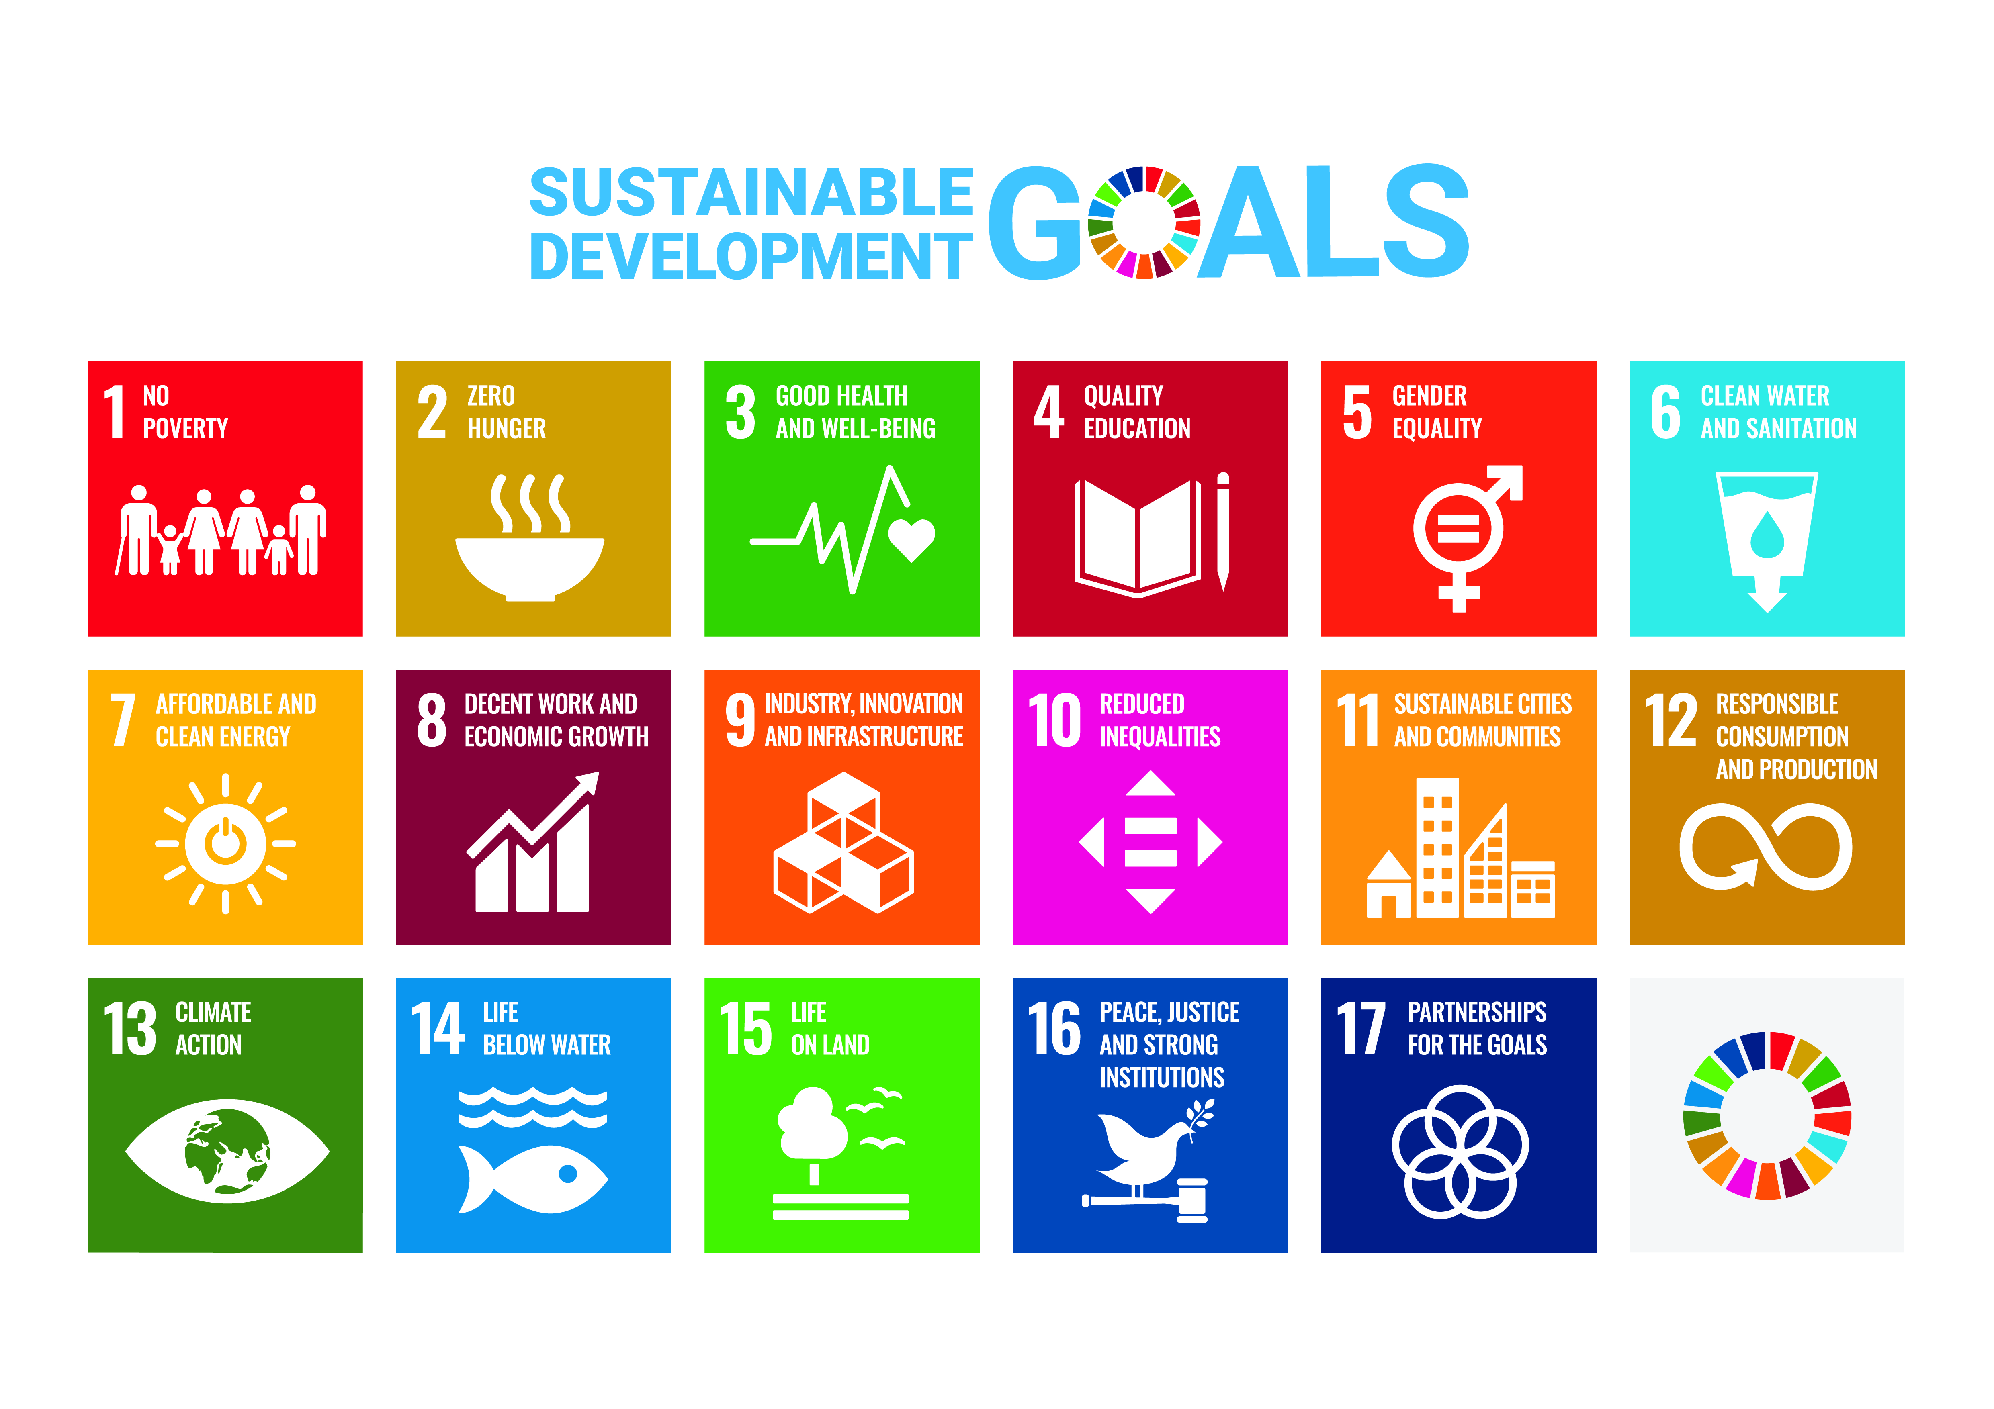

Tentative Course Schedule
Day | Topic | Content/Activities
1 | Introduction | - Syllabus review  - Material: ICT handout  - e-Portfolio Manual
2 | Introduction | - Questions about syllabus (kahoot)  - e-Portfolio explanation  - Enroll in Moodle course  - Update Moodle info  - Vocabulary activity
3 | Introduction | - Review e-Portfolios  - Make secret URLs and submit
4 | ICT Basics | - Keyboard  - Mouse  - Vocabulary
5 | ICT Basics | - Review homework  - Keyboard shortcuts
6 | ICT Basics | - File types (docx, xlsx, zip,…)  - Organizing your files
7 | e-Mail | - Review vocab (kahoot)  - new vocabulary  - email (PPT)  - Reply, Reply to all, Forward  - Attachments  - Task based activity
8 | e-Mail | - write different emails for different situations (handout)
9 | Typing | - Introduction to typing  - Typing Practice  - - Handout: "Emergency …"  - - Handout: "harry Potter …"  - Explain the Typing Practice Results (handout)
10 | Text Editors | - Check homework  - Vocabulary  - MS Word screen (on the projector)
11 | Text Editors | - Keyboard Layout (handout)  - Shortcuts in word practice (handout)
12 | Text Editors | - Document Formatting  - class format  - practice fixing text (Moodle)
13 | Text Editors | - Working with images in MS Word  - Additional Vocabulary  - Activity: Word Hunt
14 | Text Editors | - MS Word advanced features:  - Headers  - ToC  - image and table captions
15 | Text Editors | - MS Word advanced features:  - Styles  - Breaks
16 | Spreadsheets | - Introduction to spreadsheet applications  - Vocabulary  - Data Entry (fill handle and data types)  - Types of graphs
17 | Spreadsheets | - Activity: Car color counting  - Formulas  - Cell references
18 | Spreadsheets | - Math operations  - percentages  - Filter and ordering
19 | Spreadsheets | - Cell properties  - Merge cell, wrap text  - Number formats  - Printing
20 | Spreadsheets | - Change cell sizes  - Formulas, equations and functions  - Charts and charting concepts
21 | Spreadsheets | - Vocabulary to describe charts  - Practice the examples in the handout
22 | Surveys and Questionnaires | - Review mistakes to avoid in a questionnaire  - Distribute Research Papers (extra handout).  - Main research paper in Moodle
23 | Surveys and Questionnaires | - Qualitative and Quantitative  - Question types  - Moral issues attached to questions  - Qualities of good questions (handout and PPT)
24 | Surveys and Questionnaires | - Make your own questions  - Interview colleagues to retrieve data
25 | Surveys and Questionnaires | - Finding information in your data  - Data Retrieval  - Data Entry  - Data Analysis
26 | Presentations | - Final Project explanation  - Basic concepts of presentation software  - Slide creation techniques  - Slide types and when to use them  - Vocabulary
27 | Presentations | - Basic Presentation with PPT  - Word Hunt PPT  - Animations and transitions
28 | Presentations | - Multimedia presentations.  - Using data and graphs  - Adding multimedia to presentations (audio and video)  - Automatic slide shows
29 | Presentations | - Analyzing presentations:  - Voice volume, eye contact and other presentation basics  - Gestures and visuals  - Voice volume, eye contact and other presentation basics  - Evaluation forms.  - Present your typing score presentation to your group
30 | Review | - Final Project Review:  - Check word file (format)  - check graphs  - Final Project rehearsals:  - distribute presentation feedback forms  - peer feedback  - relaxing on stage  - speaking more fluently
 | Final Examination
Required Materials:
Course Materials
- There is no course textbook. Instead, readings and activity sheets will be given in class.
- You will need a binder or folder to store class handouts.
- Other resources will be available on the Moodle class website.
- Students are required to have earphones for listening to audio files both inside and outside class.
- This course will be using the e-Portfolio system extensively. Please make sure you have a tablet or a personal computer to complete homework assignments.

Course Policies (Attendance, etc.)
Student Responsibilities
As a class member, you are responsible for attending all classes and arriving on time, for participating as a member of a group, and for completing and handing in all assigned work.
クラスの一員として、すべてのクラスに出席し、予定通りに到着すること、グループの一員として参加すること、および割り当てられたすべての作業を完了して処理することに対して責任があります。

Attendance and Lateness
- You can be absent a maximum of 5 times.
５回まで欠席が出来ます。
- If you are more than 20 minutes late, you will be given an absence
20分以上遅れた場合は、欠席となります。
- Two lateness are equal to one absence.
2回の遅刻は1回の欠席に等しいです。
If you sum up more than 5 absences (e.g. 4 absences and 3 lateness), you will have to withdraw from the course. Failing to do so will result in an automatic “F” grade.
5回以上の欠席の場合（例：４回欠席と3回遅刻）、撤退をしないといけないです。撤退しないと、自動的に「F」グレードになります。

Homework
The homework should be handed in at the beginning of every class. All homework submitted after that will not be considered.
宿題はクラスの始めに渡されるべきです。それ以降には考慮されません。

Excused Absences
Whenever possible, plan in advance and ask the instructors for the material of the class you are going to be absent. Homework and project deadlines will not be changed nor postponed, so plan ahead of time if you have to be absent for a class. Exceptional cases exist, so be sure to talk to the instructor if you have any questions/doubts.
可能であれば、事前に計画を立て、欠席するクラスの教材を講師に尋ねてください。 宿題やプロジェクトの締め切りは変更も延期もされないので、授業に欠席する必要がある場合は事前に計画してください。例外的なケースがありますので、質問や疑問がある場合は必ず講師に相談してください。

Late Assignments
It is your responsibility to look for the instructors and check what assignments are due.
Also, if you miss a class, it is your responsibility to contact the instructors to get handouts and explanations (missing a class is no excuse for not handing in homework).
講師を探し、どの課題が予定されているかを確認するのはあなたの責任です。
また、授業を欠席した場合は、講師に連絡して欠席した授業の資料や説明を受けてください。

Plagiarism and Intellectual Honesty
Plagiarism is representing someone else's intellectual property, words, ideas, or images, as your own. It is a very serious academic offense and plagiarized work is not accepted in this course. Ask one of the instructors if you have any questions about this. You are responsible for understanding what plagiarism is and knowing how to avoid it in your work.
盗作とは、他人の知的財産、言葉、アイデア、または画像を自分のものとして表すことです。これは非常に深刻な学術的な違反であり、このコースでは盗用された作品は受け入れられません。あなたがこれについて何か質問があるかどうか講師の一人に尋ねてください。あなたは盗作とは何かを理解し、あなたの仕事の中でそれを回避する方法を知っている責任があります。

Class Preparation and Review
Students are expected to spend at least one hour preparing for every hour of lesson, and one hour reviewing and doing homework. Make sure you review your notes after each class and make sure you understand the topics covered. Instructors are available outside the classroom in case students need additional assistance (Please check office hours on the first page of this syllabus).
授業の1時間ごとに最低1時間の準備をし、1時間を検討して宿題をすることが求められます。 クラスの後にノートを見直して、カバーされたトピックを理解していることを確認してください。学生が追加の援助を必要とする場合、講師は授業時間外で利用できます（このシラバスの最初のページに勤務時間を確認してください）。

You will have many homework assignments. Make sure you review those before coming to the next class. Also, check the class Content/Activities so you can be prepared for the class.
宿題はたくさんあります。 次のクラスに進む前に、必ずそれらを見直してください。 また、クラスのコンテンツ/アクティビティを確認して、クラスに備えることができるようにします。

Grades and Grading Standards
You will be graded on quizzes, assignments and projects, class attendance and participation, and individual effort. The weights given to them will be as follows:

• Homework & e-Portfolio 20%
• Tests (content & language) 50%
• Final Project 30%

You will receive a mid-semester evaluation to let you know how you have been doing up to that point.
その時点までにどのようにしてきたかを知らせるために学期半ばの評価を受けるでしょう。

Methods of Student Feedback:
Homework assignments will be graded and returned within a week of submission. Additional comments and feedback will be given verbally in class, but students are encouraged to come to instructor’s office during office hours in case extra explanations are needed.
宿題は提出後1週間以内に採点され、返却されます。追加のコメントやフィードバックは口頭でクラスで行われますが、追加の説明が必要な場合には、学生は勤務時間内に講師のオフィスに来ることをお勧めします。

Tests are usually graded using a rubric which will be made available and explained during the test period. Students are encouraged to ask additional clarification before the test starts.
全てのテストはるルーブリックがあります。テスト期間中に説明されます。テストを開始する前に、生徒は追加の説明を求めることをお勧めします。

Participation is required not only answering questions, but also asking questions.
参加は、質問を答えるだけではなく、質問をすることも必要です。

Diploma Policy Objectives:
Work completed in this course helps students achieve the following Diploma Policy objective(s):
① Advanced thinking skills
③ The ability to identify and solve problems
④ Advanced communicative proficiency in both Japanese and English
⑤ Proficiency in the use of information technology

SILA Course Skills
This course aims at developing the following skills:

[ ] Present confidently in Japanese
[ ] Express ideas persuasively using spoken Japanese
[ ] Make concise & complete answers in Japanese
[ ] Write ideas in Japanese
[ ] Express ideas about the text or discussion in Japanese
[ ] Read critically in Japanese
[ ] Find important points in texts for discussion in Japanese
[ ] Make interesting opinions about the texts and support opinions with good reasons in Japanese
[ ] Speak clearly with a natural rhythm in English
[✕] Speak accurately with appropriate vocab. for the situation in English
[ ] Initiate and maintain conversations in English
[ ] Write ideas with developed arguments in English
[✕] Use multiple grammar structures accurately in English
[ ] Structure text logically & coherently in English
[ ] Read quickly & understand in English
[ ] Check understanding by summarizing texts in English
[✕] Use word processing software effectively
[✕] Use spreadsheet software
[✕] Make good quality presentation materials
[✕] Interchange data among word processing, spreadsheet and presentation software
[✕] Save data, and manage files and folders
[✕] Type quickly & use keyboard shortcuts
[✕] Write business & personal emails
[✕] Find useful information on the Internet
[✕] Gather knowledge & form opinions about current events
[ ] Understand and share feelings of inequality
[ ] Understand and share feelings of cultural differences
[ ] Describe how views on cultural differences & social inequalities have changed as a result of increased knowledge of the world
[ ] Demonstrate knowledge, abilities & attitudes from study abroad program through the study abroad portfolio
[ ] Summarize concepts of social science, general science and the humanities
[ ] Combine concepts of social science, physical science and humanities into a bigger picture
[ ] Give a brief statement of the concepts of social science, general science and the humanities
[✕] Evaluate data or evidence and make a logical conclusion
[✕] Think about conclusions that are based upon data or evidence, and decide if those conclusions are good or not
[ ] Judge if I have all the information that is needed to make a good conclusion, and what other information might be required
[ ] Avoid making mistakes in arguments, and identify mistakes that other people make
[ ] Decide how accurate a conclusion is, using the evidence provided
[✕] Use information from a variety of sources to decide what might be accurate
[✕] Understand when and how things are related, and when they are not
[✕] Decide if information or sources of information can be trusted or not

Notes
To make sure students remember class contents, we will use classroom response systems sometimes. Usually, review will be conducted at the beginning of a class and hopefully we can have some discussion during it. No special hardware is required because we will be using the computers available in the computer lab. In case you want to use your own computer, tablet or smartphone, there is no problem.
学生がクラスの内容を覚えていることを確認するために、スチューデントレスポンスシステム (SRS)を使用することがあります。通常、レビューは授業の最初に行われて、授業中に議論ができることを願います。コンピュータ教室のパソコンを使用するので、特別なハードウェアの必要がありません。しかし、自分の端末（パソコンやスマホ）を使用することも出来ます。

Information and Communication Technology Rubrics & Badges

Contents
Rubrics 13
Writing Rubrics 13
Spreadsheet Rubrics 15
Presentation Rubric 16
Class Behavior 19
Badges 20
Category: Language 20
Category: Extra Skills 21
Category: Main IT skills 22
Category: Secondary IT skills 23

Rubrics

Writing Rubrics
ELEMENT | Exemplary  (3 points) | Proficient  (2 points) | Partially Proficient  (1 point) | Unsatisfactory  (0 points) | POINTS
Pre Production / Drafts | Student clearly have written several drafts before engaging in writing the final assignment.  Effectively used mind mapping and/or brainstorming. | Student wrote at least a draft before submitting the final work.  Mind mapping/brainstorming may be not present but review of draft might make up for it. | Student did at least one of the following:  - draft  - mind mapping  - brainstorm | No drafts, no mind mapping and no brainstorming before start writing the final work. | ___/3
Research Questions | Wrote thoughtful, creative, well-worded specific questions that were relevant to the assigned topic. | Wrote well-worded, specific questions that were relevant to the assigned topic. | Wrote questions which lacked focus, were poorly stated, and were not entirely relevant to the assigned topic. | Wrote questions which lacked a specific focus, were poorly stated, and not relevant to the assigned topic. | ___/3
Content | The content is written clearly and concisely with a logical progression of ideas and supporting information.  The project includes strong, rich supporting details and examples that prove thesis.  Meaningful conclusion that explains not only the importance of the research as well as how it can be used. | The content is written with a logical progression of ideas and supporting information.  Includes persuasive information from reliable sources.  Clear conclusion as showing why the research is relevant. | The content is vague in conveying a point of view and does not create a strong sense of purpose.  Includes some persuasive information with few facts.  Some of the information may not seem to fit.  Sources used appear unreliable. | The content lacks a clear point of view and logical sequence of information.  Missing support details  Information is incomplete, out of date and/or incorrect.  Sequencing of ideas is unclear.  Missing a summarizing conclusion | ___/3
Layout | The layout follows all class standards. | The layout uses most of class standards. | Student used some class standards. | The layout does not follow any class standard or too little | ___/3
Selection of Sources / Citations | Sources of information are properly cited  Source credibility and authority is assured.  All sources of information are clearly identified and credited using appropriate citation format.  Identified highly appropriate sources in a variety of formats (books, journals, electronic sources). | Most sources of information use proper citation format, and sources are documented to make it possible to check on the accuracy of information.  Identified mostly appropriate sources in a variety of formats (books, journals, electronic sources). | Sometimes copyright guidelines are followed and some information, photos and graphics do not include proper citation format.  Identified a few appropriate sources but made little attempt to balance format types. | No way to check validity of information.  Identified no appropriate sources in any format. | ___/3
Graphics, Sound and/or Animation | The graphics and images have proper size and resolution, and all images enhance the content.  There is a consistent visual theme. | The graphics and images help the reader to understand the flow of information or content.  Images are proper size, resolution. | Some of the graphics and images seem unrelated to the topic/theme and do not enhance the overall concepts.  Most images are of poor quality (clip arts or recycled from the internet).  Images are too large/small in size.  Images are poorly cropped or the color/resolution is fuzzy. | The graphics and images are unrelated to the content.  Graphics do not enhance understanding of the content, or are distracting decorations that create a busy feeling and detract from the content. | ___/3
Writing Mechanics | The text is written with no errors in grammar, capitalization, punctuation, and spelling. | The text is clearly written with little or no editing required for grammar, punctuation, and spelling. | Spelling, punctuation, and grammar errors distract or impair readability.  (3 or more errors) | Errors in spelling, capitalization, punctuation, usage and grammar repeatedly distract the reader and major editing and revision is required.  (more than 5 errors) | ___/3
TOTAL POINTS |  |  |  |  | ___ /21

Spreadsheet Rubrics
ELEMENT | Exemplary  (3 points) | Proficient  (2 points) | Partially Proficient  (1 point) | Unsatisfactory  (0 points) | POINTS
Title:  Merged and Centered | Title is merged and centered at the top of the spreadsheet. Font size, style ,and colors are used to enhance appearance. | Title is merged and centered and is at the top of the page. Title has some mini-mal formatting with size, style, or colors. | Title is at the top of the page, but is not merged and /or centered. Title formatting is minimal. | Title is not merged and centered, not at the top of the spread-sheet , not formatted, or not relevant to the topic. | ___/3
Data entry:  Labels, values and formulas | All labels (text) fit within a single column. Values (numbers) are appropriate and formatted correctly. All Formulas work | Most labels fit within a single column. Most numbers are appropriate and formatted correctly. Some formulas work. | Few of the labels fit within a single column. Few numbers are appropriate to the topic. (too high, low) Some formulas don’t work. | No labels fit within a single column. All or most numbers are nonsensical or inappropriate for the chart topic  No formulas work. | ___/3
Chart | The chart fits the data well and is easy to interpret. Uses colors, data labels, legends, and other chart formatting well. | The chart is adequate, has some formatting. but is somewhat difficult to interpret. | The chart is difficult to interpret. Labels and important descriptions may be missing or confusing. | The chart is missing or does not relate to the data clearly. Chart is confusing making interpretation impossible. | ___/3
Organization | The spreadsheet and chart have an excellent design and layout. It is neat and easy to understand the con-tent. Fits on a single page for printing. | The project has a nice design and layout. It is neat and easy to read. Fits on a single page for printing. | The project needs improvement in design, layout or neatness. May not fit on a single page for printing. | The project needs significant improvement in design, layout and neatness. Does not fit on a single page for printing. | ___/3
Writing Mechanics:  Spelling, Grammar, Punctuation and Capitalization | The text is written with no errors in grammar, capitalization, punctuation, and spelling. | The text is clearly written with little or no editing required for grammar, punctuation, and spelling. | Spelling, punctuation, and grammar errors distract or impair readability.  (3 or more errors) | Errors in spelling, capitalization, punctuation, usage and grammar repeatedly distract the reader and major editing and revision is required.  (more than 5 errors) | ___/3
TOTAL POINTS |  |  |  |  | ___ /15
Adapted from: http://oakdome.com/k5/file-downloads/rubric-for-spreadsheet-with-chart.php

Presentation Rubric
ELEMENT | Exemplary  (3 points) | Proficient  (2 points) | Partially Proficient  (1 point) | Unsatisfactory  (0 points) | POINTS
Research and Note taking | Researched a variety of information sources, recorded and interpreted significant facts, meaningful graphics, accurate sounds and evaluated alternative points of view. | Recorded relevant information from multiple sources of information, evaluated and synthesized relevant information. | Misinterpreted statements, graphics and questions and failed to identify relevant arguments. | Recorded information from four or less resources, did not find graphics or sounds, and ignored alternative points of view. | __/3
Pre Production Planning - Storyboard | The storyboard illustrates the slide presentation structure with thumbnail sketches of each slide including: title of slide, text, background color, placement & size of graphic, fonts - color, size, type for text and headings, hyperlinks (list URLs of any site linked from the slide), narration text, and audio files (if any). All slides are numbered, and there is a logical sequence to the presentation. | The thumbnail sketches on the storyboard include titles and text for each slide and are in sequential order. | The thumbnail sketches on the storyboard are not in a logical sequence and have incomplete information. | There a very few thumbnail sketches on the storyboard and do not provide an overview of the presentation. | ___/3
Content | The content is written clearly and concisely with a logical progression of ideas and supporting information.  The project includes motivating questions and advanced organizers. The project gives the audience a clear sense of the main idea.  Information is accurate, current and comes mainly from * primary sources. | The content is written with a logical progression of ideas and supporting information.  Includes persuasive information from reliable sources. | The content is vague in conveying a point of view and does not create a strong sense of purpose.  Includes some persuasive information with few facts.  Some of the information may not seem to fit.  Sources used appear unreliable. | The content lacks a clear point of view and logical sequence of information.  Includes little persuasive information and only one or two facts about the topic.  Information is incomplete, out of date and/or incorrect.  Sequencing of ideas is unclear. | ___/3
Text | The fonts are easy-to-read and point size varies appropriately for headings and text.  Use of italics, bold, and indentations enhances readability.  Text is appropriate in length for the target audience and to the point.  The background and colors enhance the readability of text. | Sometimes the fonts are easy-to-read, but in a few places the use of fonts, italics, bold, long paragraphs, color or busy background detracts and does not enhance readability. | Overall readability is difficult with lengthy paragraphs, too many different fonts, dark or busy background, overuse of bold or lack of appropriate indentations of text. | The text is extremely difficult to read with long blocks of text and small point size of fonts, inappropriate contrasting colors, poor use of headings, subheadings, indentations, or bold formatting. | ___/3
Introduction | The introduction presents the overall topic and draws the audience into the presentation with compelling questions or by relating to the audience's interests or goals. | The introduction is clear and coherent and relates to the topic. | The introduction shows some structure but does not create a strong sense of what is to follow. May be overly detailed or incomplete and is somewhat appealing to the audience. | The introduction does not orient the audience to what will follow.  The sequencing is unclear and does not appear interesting or relevant to the audience. | ___/3
Layout | The layout is visually pleasing and contributes to the overall message with appropriate use of headings, subheadings and white space. | The layout uses horizontal and vertical white space appropriately. | The layout shows some structure, but appears cluttered and busy or distracting with large gaps of white space or uses a distracting background. | The layout is cluttered, confusing, and does not use spacing, headings and subheadings to enhance the readability. | ___/3
Graphics, Sound and/or Animation | The graphics, sound and/or animation assist in presenting an overall theme and enhance understanding of concept, ideas and relationships.  Original images are created using proper size and resolution, and all images enhance the content.  There is a consistent visual theme. | The graphics, sound/and or animation visually depict material and assist the audience in understanding the flow of information or content.  Original images are used.  Images are proper size, resolution. | Some of the graphics, sounds, and/or animations seem unrelated to the topic/theme and do not enhance the overall concepts.  Most images are clip art or recycled from the internet.  Images are too large/small in size.  Images are poorly cropped or the color/resolution is fuzzy. | The graphics, sounds, and/or animations are unrelated to the content.  Graphics do not enhance understanding of the content, or are distracting decorations that create a busy feeling and detract from the content. | ___/3
Citations | Sources of information are properly cited and the audience can determine the credibility and authority of the information presented.  All sources of information are clearly identified and credited using appropriate citation format. | Most sources of information use proper citation format, and sources are documented to make it possible to check on the accuracy of information. | Sometimes copyright guidelines are followed and some information, photos and graphics do not include proper citation format. | No way to check validity of information. | ___/3
Writing Mechanics | The text is written with no errors in grammar, capitalization, punctuation, and spelling. | The text is clearly written with little or no editing required for grammar, punctuation, and spelling. | Spelling, punctuation, and grammar errors distract or impair readability.  (3 or more errors) | Errors in spelling, capitalization, punctuation, usage and grammar repeatedly distract the reader and major editing and revision is required.  (more than 5 errors) | ___/3
TOTAL POINTS |  |  |  |  | ___ /27
Adapted and used with permission from Joan M. Vandervelde
Original online at: https://www2.uwstout.edu/content/profdev/rubrics/pptrubric.html

Class Behavior
ELEMENT | Exemplary  (3 points) | Proficient  (2 points) | Partially Proficient  (1 point) | Unsatisfactory  (0 points) | POINTS
Classroom language | Use English during the whole class.  Makes extra effort to explain things using different explanations / vocabulary | Makes efforts to communicate in English and make use of gestures/drawings to be understood | Makes some effort to communicate in English but relies on Japanese as soon as possible. | Makes no effort to communicate in English inside the classroom. | ___/3
Cooperative Group Work | Works well with others. Assumes a clear role and related responsibilities. Motivates others to do their best. | Works well with others. Takes part in most decisions and contributes fair share to group. | Works with others, but has difficulty sharing decisions and responsibilities. | Cannot work with others in most situations.  Cannot share decisions or responsibilities. | ___/3
Participation | Often asks questions and shows interest to deepen knowledge | Ask questions eventually.  Is often ready to answer question when asked directly. | Do not ask questions in front of peers.  When asked a question, often can not answer. | Do not ask questions and/or participate only when asked directly. | ___/3
Posture | Always willing to help peers.  Often helps peers after finishing a class assignment. | Tries hard to complete class assignments.  Sometimes able to help peers.  Very often, can figure out solutions for problems without instructor’s help. | Do some effort to complete class assignments  Usually asks for help as soon as something difficulty shows up. | Usually sleepy.  Do not make effort to complete class assignments  Waits for instructors to come and check the work done. | ___/3
Preparation | Homework thoroughly completed.  Read all materials and ready for class discussion. | Homework completed with minor mistakes or need more review  Read the materials but still lack full understanding | Homework incomplete or major mistakes.  Missing non-essential material for class | No homework.  Forgot to bring material to class.  Unprepared to participate in class discussion | ___/3
TOTAL POINTS |  |  |  |  | ___ /15

Badges

Category: Language
Image | How to earn this badge? | What does it mean?
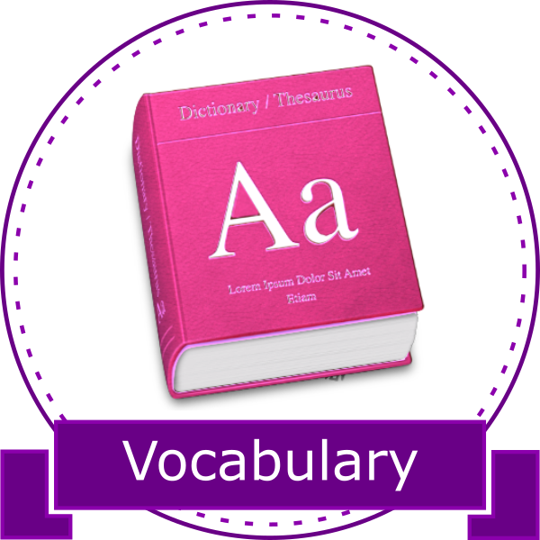 | Students who achieve a minimum of 80% in the vocabulary tests. | Students have a good understanding of the vocabulary used in class.
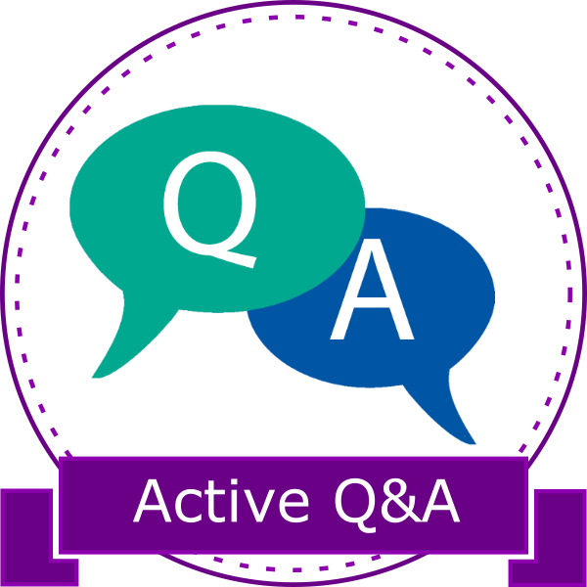 | Students who are able to articulate questions and make comments in class. | Students participate actively in class, are able to follow explanations without much difficulty and help the overall class flow.
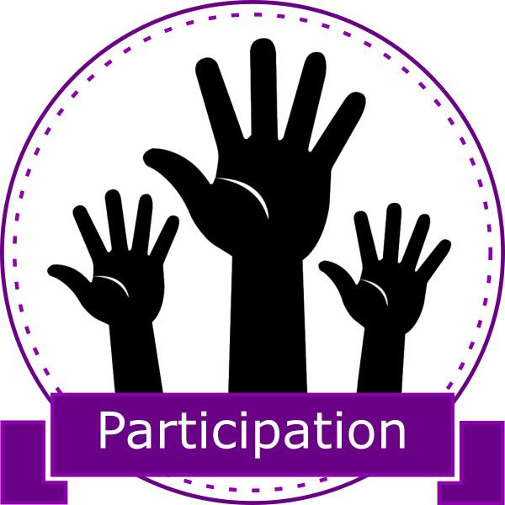 | Students who are able to answer class-wide questions | Students are able to answer questions that are not directly asked to them. Even when not knowing the answer,
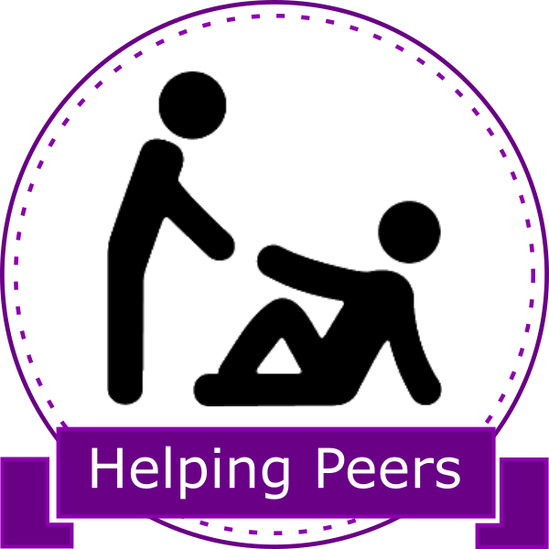 | Students who help their peers in class | Students are actively helping their peers, not performing the tasks for them, but helping them to understand and providing explanation that build up on instructor’s.

Category: Extra Skills
Image | How to earn this badge? | What does it mean?
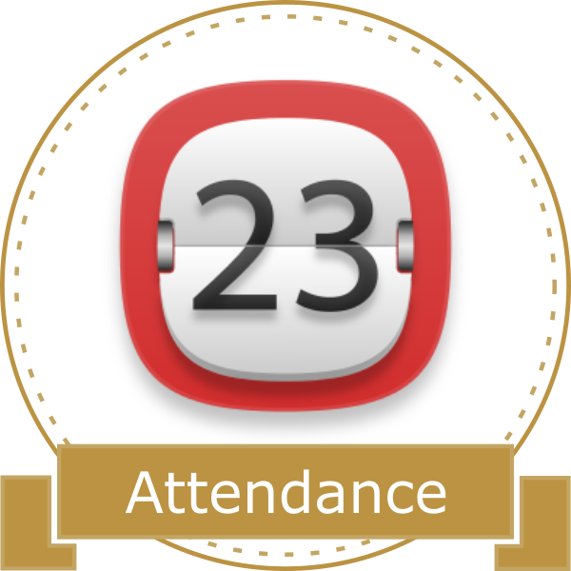 | Students who do not miss any class. | Students are assiduous learners and take attendance seriously.
 | Students who are always on time for class. | Students are able to manage their time and as a result have no time schedule conflicts and are always on time for class
 | Students whose portfolio shows clear self-assessment and visualization of learning outcomes. | Students have a concrete tool to showcase their work with documents that prove formal and informal learning. These students are able to understand that the learning process is as important as the final artifact submitted for evaluation.
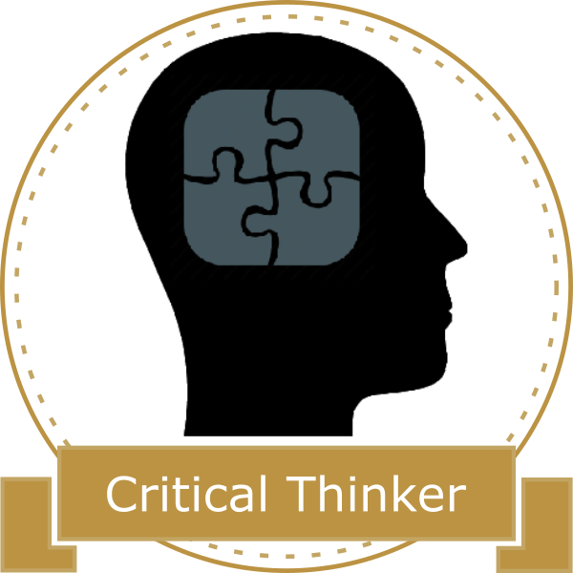 | Students who think critically in order to solve a task or problem. | Students are able to use previous knowledge to solve class tasks and problems. Their resolutions are comprehensive and well-reasoned.

Category: Main IT skills
Image | How to earn this badge? | What does it mean?
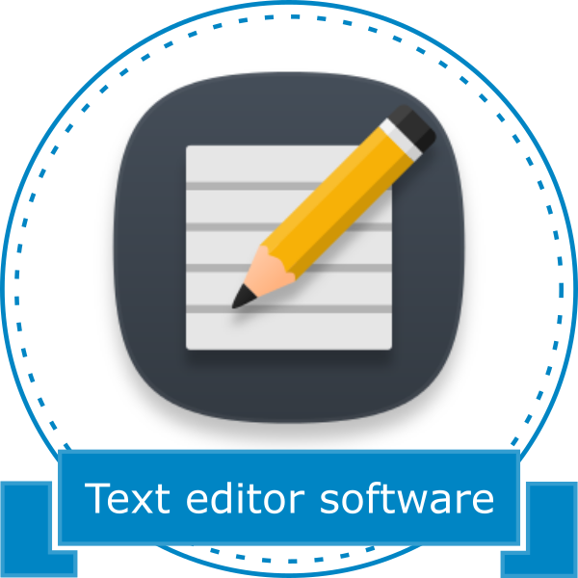 | Students who achieve more than 80% in the text editor software rubric. | Students are able to change basic properties of their documents like margins and styles as well as dealing with document sections.
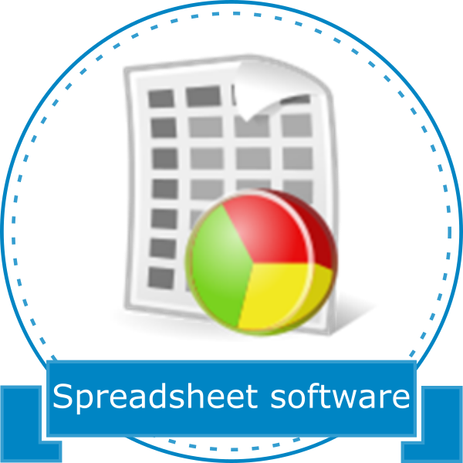 | Students who achieve more than 80% in the spreadsheet software rubric. | Students are proficient with data retrieval, data entry and data analysis.
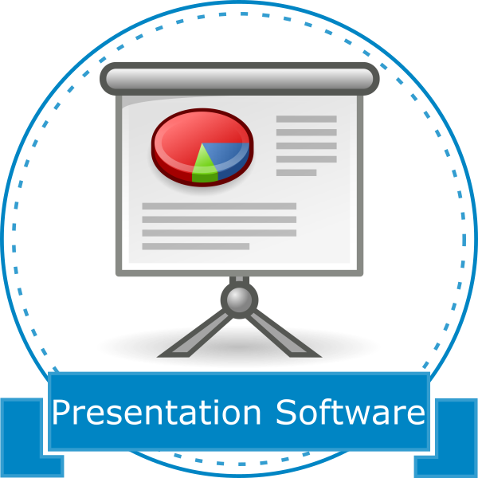 | Students who achieve more than 80% in the presentation software rubric. | Students are able to create concise presentations that are informative and keep the audience engaged.

Category: Secondary IT skills
Image | How to earn this badge? | What does it mean?
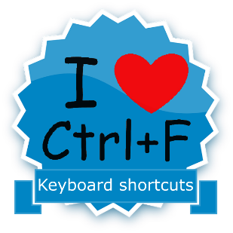 | This badge is awarded to all students who have good knowledge of keyboard shortcuts and actively use them. | Students who make use of shortcuts can enhance their productivity and complete tasks faster
 | To earn this badge, students must communicate properly by email. This can be demonstrated by communicating problems in advance or simply by asking help/advice by e-mail. | This badge shows that students are proficient using e-mail for communicating with colleagues, professors and people they do not know.  Being able to communicate effectively using e-mail is very helpful for students inside and outside MIC.
 | In order to earn this badge students must keep good organization of their files in the portfolio as well as paper handouts. | File organization is not as easy as it looks like and having such skill will help students keeping track of tasks, studying, recognizing information relevance and manage priorities.
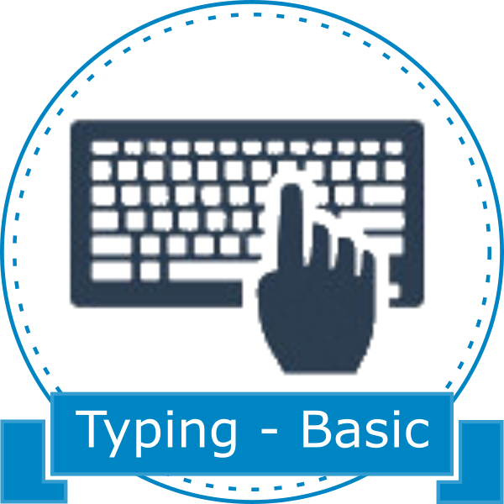 | Students who have an average typing speed equal or higher than 30 WPM | Students are able to type without making observers nervous.
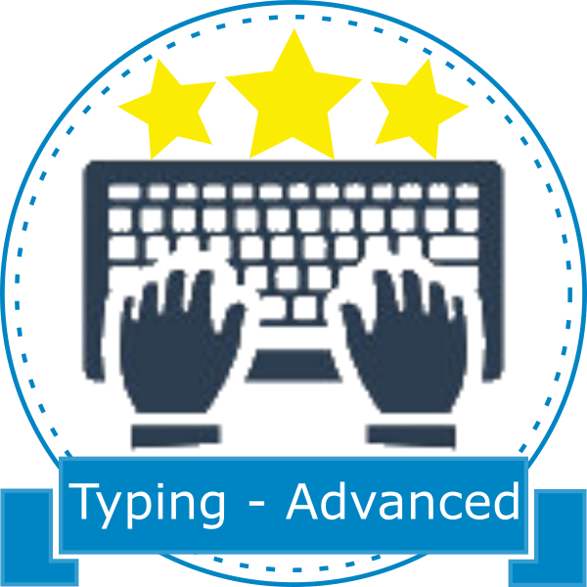 | Students who have an average typing speed equal or higher than 45 WPM | Students are quite proficient typing and are able to finish writing assignments faster.
 | Students who achieve more than 80% in the presentation skills rubric. | Students are able to present their ideas clearly during presentations. Answer to questions are clear and to the point.

